Network Traffic Prediction and Congestion Optimization Using Numerical Methods
Course: BM371 – Numerical Methods
Project Type: Networking Application Using Numerical Methods
Tools Used: Python, NumPy, Matplotlib, Cisco Packet Tracer

Abstract
This project presents an enterprise network traffic prediction and congestion optimization system using numerical methods. The system integrates networking principles with computational techniques such as Newton interpolation and Newton-Raphson optimization to simulate, analyze, and optimize traffic behavior within a segmented enterprise network. Cisco Packet Tracer was used to construct the network topology, while Python was used to develop the traffic analytics and optimization engine. The system predicts future traffic loads, detects congestion conditions, and computes optimal bandwidth allocation to reduce delay and improve network efficiency.

1. Introduction
Modern enterprise networks experience continuously changing traffic loads due to streaming services, VoIP communication, cloud applications, and file transfers. These traffic variations may cause congestion, packet loss, and increased latency. Traditional static network allocation methods are insufficient for dynamic traffic conditions. Therefore, numerical methods can be used to predict traffic patterns and optimize bandwidth allocation.

2. Project Objectives
- Design and simulate an enterprise network topology.
- Generate and analyze network traffic patterns.
- Predict future traffic using Newton interpolation.
- Detect congestion conditions dynamically.
- Optimize bandwidth allocation using Newton-Raphson method.
- Visualize traffic behavior and optimization results.

3. Enterprise Network Design
The enterprise network consists of three departments connected through VLAN segmentation and router-on-a-stick inter-VLAN routing. The topology includes a core switch, three access switches, one router, servers, and multiple PCs.
Department | VLAN | Subnet
Department A | 10 | 192.168.10.0/24
Department B | 20 | 192.168.20.0/24
Department C | 30 | 192.168.30.0/24

4. Numerical Methods Used

4.1 Newton Interpolation
Newton divided-difference interpolation was used to predict future network traffic values based on previously observed traffic measurements.

4.2 Newton-Raphson Optimization
The Newton-Raphson method was used to minimize the network delay function and determine the optimal bandwidth allocation.
Delay Function: D(x) = 100/x + 0.5x

5. Real-Time Traffic Simulation
The Python system continuously generates simulated enterprise traffic in real time. Traffic categories include web browsing, VoIP communication, streaming services, and file transfer activities. Congestion severity levels are classified as normal, moderate, or critical based on link utilization.

6. Results and Analysis
The developed system successfully simulated enterprise traffic behavior and dynamically predicted congestion conditions. Department A consistently generated the highest traffic load due to multimedia and file transfer operations.
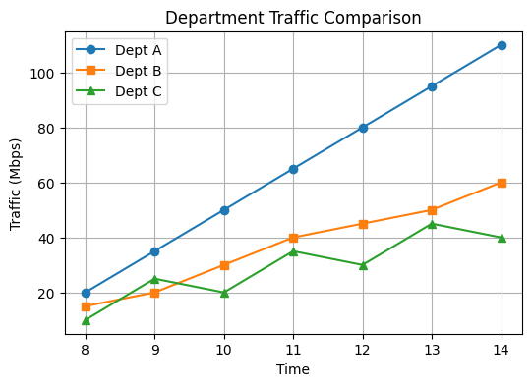
Figure 1: Department Traffic Comparison
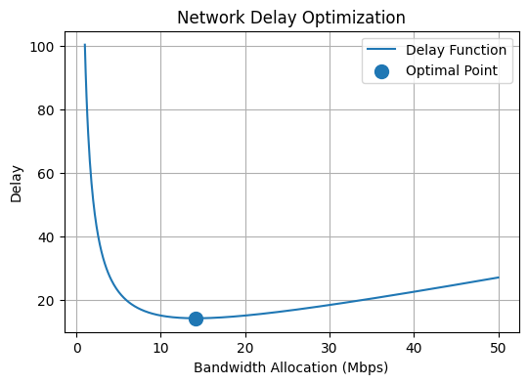
Figure 2: Network Delay Optimization

7. Graph Results Discussion

7.1 Department A Traffic Prediction Graph
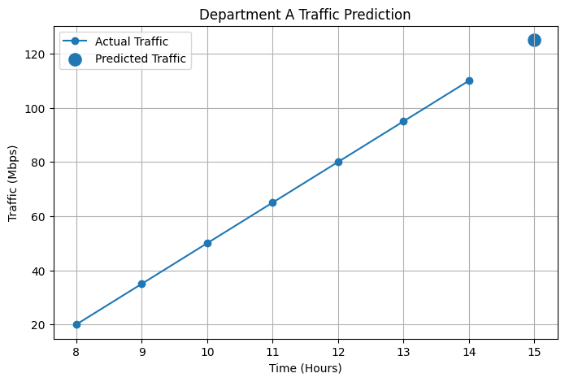
The traffic prediction graph demonstrates the effectiveness of Newton interpolation in forecasting future network traffic. The graph shows a steady increase in Department A traffic throughout the working hours, indicating high utilization caused by streaming, VoIP communication, and file transfer activities. The predicted point at 15:00 indicates that traffic is expected to continue increasing, which may lead to congestion if no optimization measures are applied.

7.2 Network Traffic Comparison Between Departments
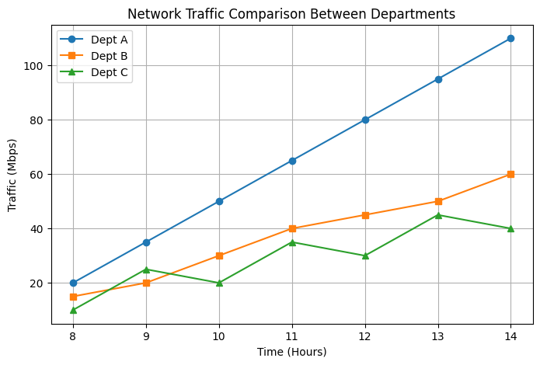
The multi-department comparison graph illustrates the difference in traffic behavior between the three departments. Department A consistently generated the highest traffic load, making it the primary bottleneck within the enterprise network. Department B exhibited moderate and stable traffic behavior, while Department C showed fluctuating burst traffic. These differences simulate realistic enterprise network conditions where departments have varying usage patterns.

7.3 Network Delay Optimization Graph
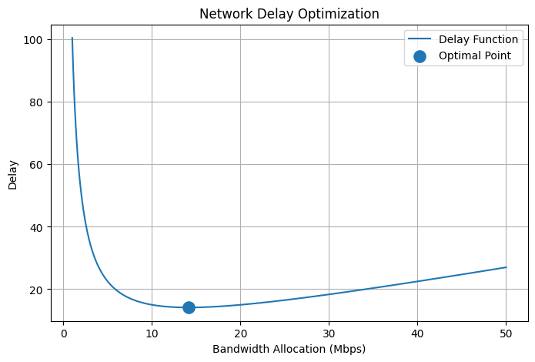
The delay optimization graph represents the relationship between bandwidth allocation and network delay. At low bandwidth values, delay is extremely high because the network becomes congested. As bandwidth increases, delay decreases significantly until an optimal point is reached. Beyond the optimal point, additional bandwidth provides diminishing improvements and may lead to inefficient resource usage. The Newton-Raphson method successfully identified the optimal operating point.

7.4 Real-Time Network Traffic Monitoring Graph
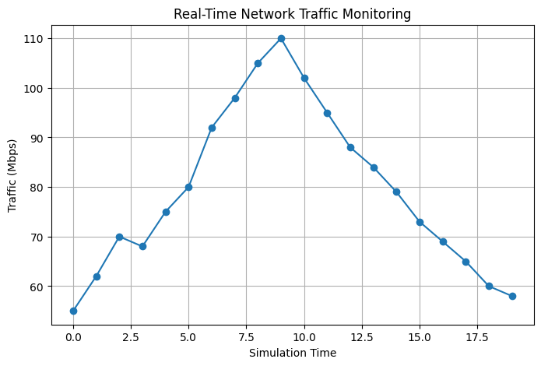
The real-time monitoring graph demonstrates the dynamic nature of enterprise traffic. Traffic levels fluctuate continuously due to changing user activity and application demands. The graph includes periods of heavy traffic where utilization approaches link capacity, simulating realistic congestion conditions. This validates the importance of real-time traffic monitoring and adaptive bandwidth optimization.

7.5 Newton-Raphson Convergence Graph
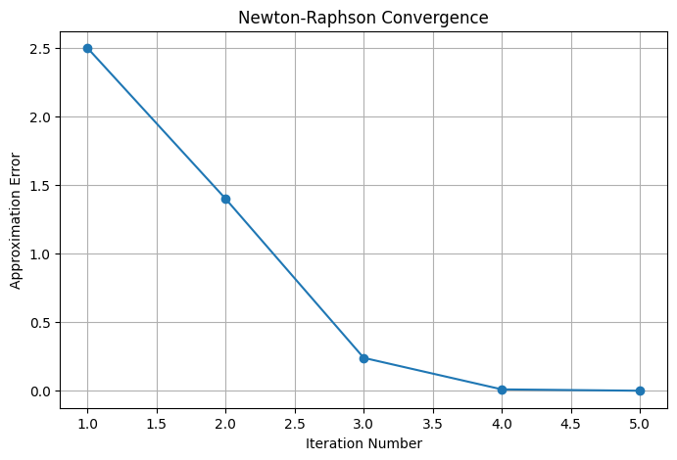
The convergence graph illustrates the numerical stability and efficiency of the Newton-Raphson optimization algorithm. The approximation error decreases rapidly with each iteration, demonstrating fast convergence toward the optimal solution. This confirms that the optimization method is computationally efficient and suitable for real-time networking applications.

8. Discussion
The numerical methods demonstrated strong performance in predicting future traffic and optimizing network delay. The interpolation model enabled traffic forecasting, while the optimization model reduced delay by identifying the ideal bandwidth allocation point. The real-time simulation improved the realism of the system and enhanced congestion analysis.

9. Conclusion
This project successfully integrated networking concepts with numerical methods to develop an intelligent enterprise traffic optimization platform. The system demonstrated the practical application of interpolation and optimization methods in networking environments. The proposed solution improved traffic analysis, congestion detection, and bandwidth optimization.

10. Future Work
- Implement machine learning-based prediction.
- Add Quality of Service (QoS) prioritization.
- Deploy the system on real network hardware.
- Develop a GUI dashboard for administrators.

11. References
Cisco Networking Academy, Introduction to Networks.
Burden, R. L., & Faires, J. D. Numerical Analysis.
Python Documentation – NumPy and Matplotlib Libraries.

